**Final Prototype**

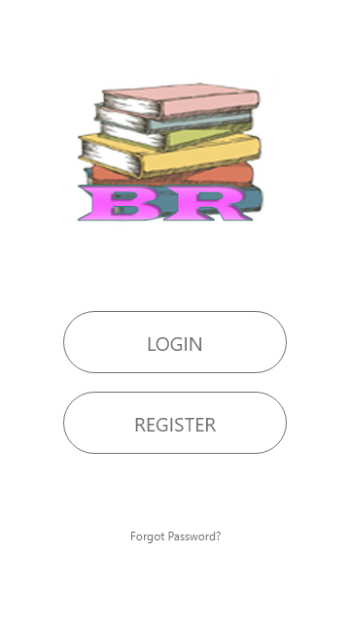

**Login Page:**

Users would land of this screen when the App is open and the user would be promoted to chose either to Login or Register, there is an option for the existing user, if they want to reset/forget the password.

**Home Page:**

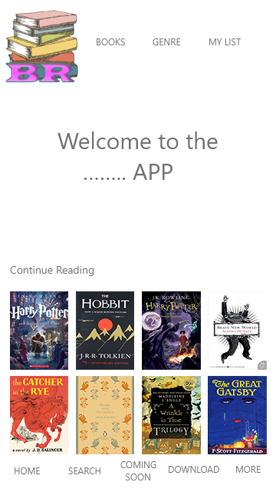Once the user has Logged In/Registered they would come to this screen where the user would be displayed books that they were reading or show them the latest trending books to read. The user would be able to navigate to the Book, Genre and My List screen through navigation.

The Bottom Navigation will allow the user to Search, Download and give access to More.

**Book Page:**

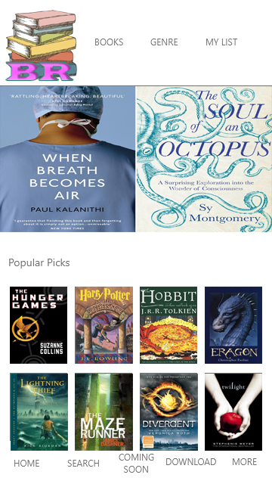When the user has chosen the Book Tab from navigation, the user would be displayed this screen showing all the trending/popular book to read based on the reviews and download. This would be constantly updated based on the people reviews and number of downloads.

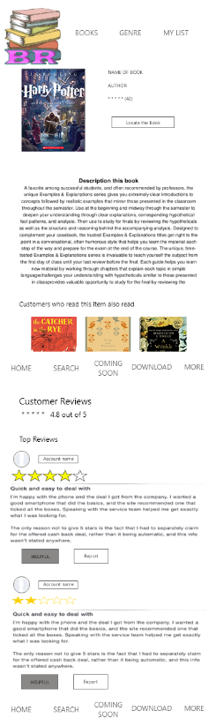**Selected Book:**

When the user selects the book, they would come to this screen showing them the brief description of the current book as well the review from the previous reader below, which is based on the user rating system.

The user would be able to Locate the book by pressing the “Locate this Book” which will take them to a live map.

There also be other book suggestion showing the users the books that previous readers have read.

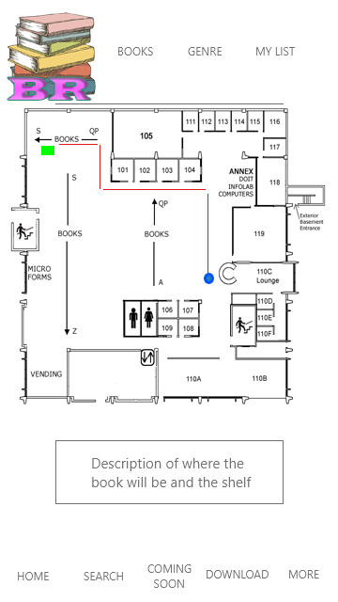.

**Live Map:**

This screen would come up when the user has selected to locate the book, this would show the user the floor plan of the building using the live location of the user’s app and the location of the book would be shown, the best route to take would also be shown to users. Once near the book the app would make a sound.

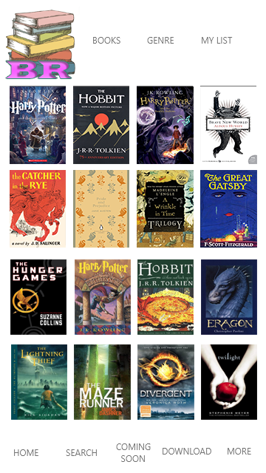**My List:**

This screen will display all the book the user has selected to read as well as the book that they have read previously.